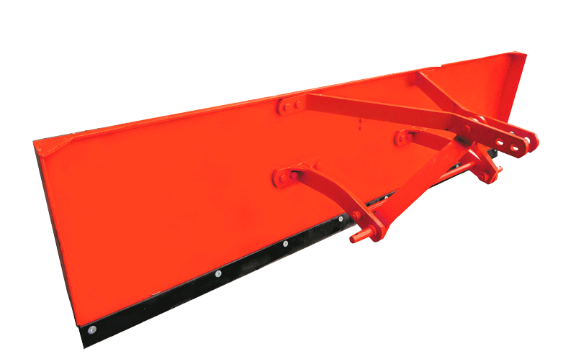 Land Leveller

Features & Benefits:

* SINGHSAKTI land levelers increase productivity and help save on the cost of irrigation.
* Available in 6, 7 and 8 feet width.
* It is a simple and rugged Implement which is directly fitted to the Tractor.
* Useful for flood irrigation.
* Leveling blade is made out of special high carbon steel which gives it double the life compared to other ordinary blades.

